**AIT-524, Class 04, Practice Problems**

**Tanmoy Chowdhury, G01025893**

As in Crow’s Foot symbol mention everything so I ignored to describe in words.

**Practice Problem 01:**

ABC Corporation has five departments: administration, marketing, sales, shipping, and purchasing. Each department employs many employees. Each employee has an ID, a name, a home address, a home phone number, a salary and Social Security number. Some employees are classified as sales representatives, some as technical support, and some as administrators. Sales representatives receive a commission based on sales. Technical support employees are required to be certified in their areas of expertise. All administrators have a title and a bonus. Given that information, create the EERD containing all primary keys, foreign keys, and main attributes.

**Solution:**

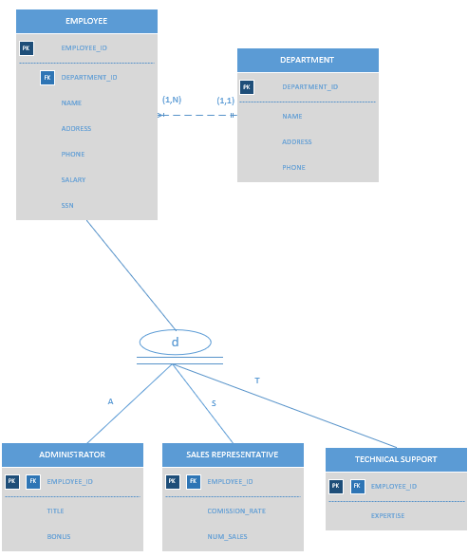

**Practice Problem 02:**

During peak periods, Temporary Employment Corporation (TEC) places temporary workers in companies. TEC’s manager gives you the following description of the business:

* TEC has a file of candidates who are willing to work and a list of companies that request temporaries.
* If the candidate has worked before, that candidate has a specific job history. Each time the candidate worked, one additional job history record was created.
* Each candidate has earned several qualifications. Each qualification may be earned by more than one candidate.
* Each time a company requests a temporary employee, TEC makes an entry in the Openings folder. That folder contains an opening number, a company name, required qualification, a starting date, an anticipated ending date, and hourly pay.
* Each opening requires only one specific or main qualification.
* When a candidate matches the qualification, (s)he is given the job and an entry is made in the Placement Record folder. That folder contains an opening number, a candidate number, the total hours worked, etc. In addition, an entry is made in the job history for the candidate.
* An opening can be filled by many candidates, and a candidate can fill many openings.

**Solution:**

